THE SEGMENTED WORLD PROJECT
The ‘real’ Segmented World
Scenario GRAPHS
2025 Update

THE THREE DRIVERS
GRAPHS
2025 Update

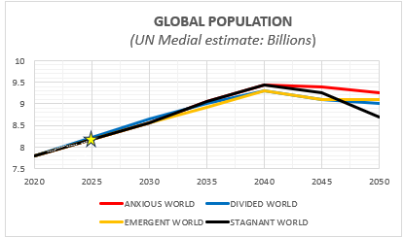

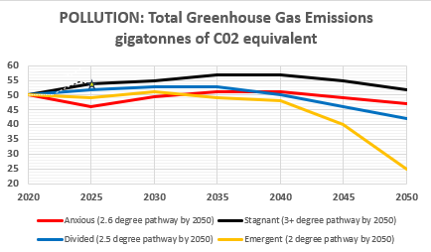

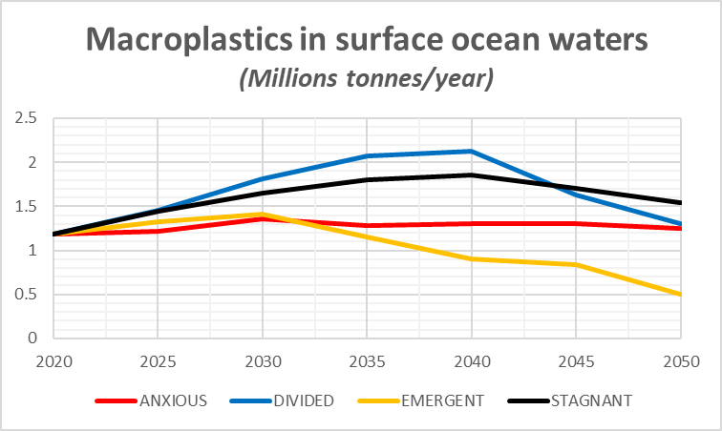
This parameter is under revision following signature of the UN Treaty on plastic pollution in August 2025 (Global Plastics Treaty negotiations (INC-5.2)
The Model will revert to using the UNIP’s Total Leakage estimates (Total Microplastic entering all aquatic environments: millions tonnes/ year). This currently uses the 2016 estimate of 19-23 million tonnes (Stephanie B. Borrelle, Chelsea M. Rochman, et al.

NO NEW DATA
•
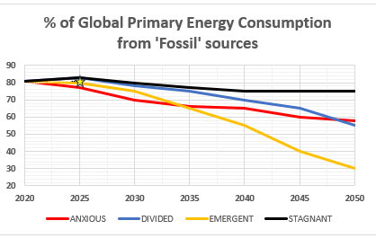
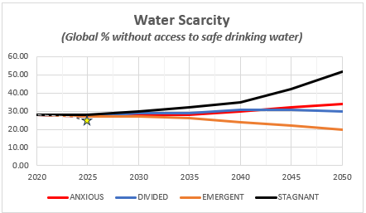

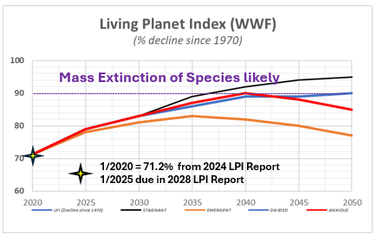

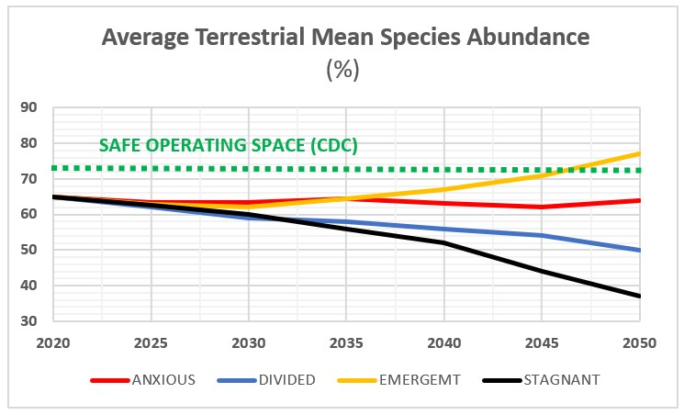

The latest authoritative measure for the Average Terrestrial Mean Species Abundance (MSA) is 0.56 (or 56%).This figure indicates that, on average, terrestrial ecosystems retain 56% of their original, undisturbed species abundance. Reference Year: 2015 (This remains the standard global baseline used in current policy assessments). Publication Date: 2020 (via the GLOBIO 4 model update).
NO NEW DATA

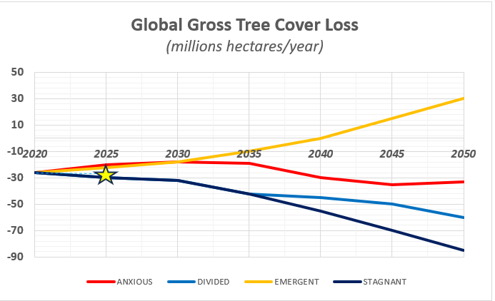

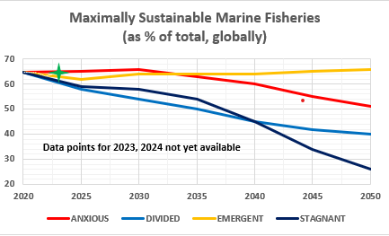
Data Lag: Although this is the "2024 report," global biological audits take years to verify. These numbers reflect the status of stocks in 2021. No comprehensive "End of 2024" data exists yet; that assessment will likely not be published until 2026
Note: Sustainable" vs. "Maximally Sustainable": When you see headlines stating that 62.3% of fisheries are sustainable, they are combining the "Maximally Sustainable" (50.5%) and "Underfished" (11.8%) categories.

NO NEW DATA

INEVITABLE CONSEQUENCES
ECONOMIC
GRAPHS
2025 Update

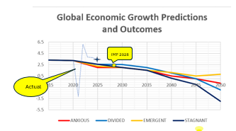

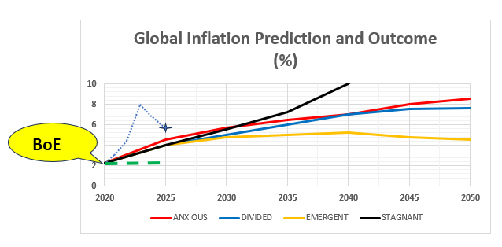

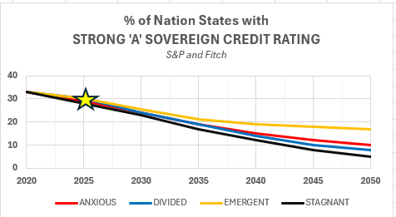

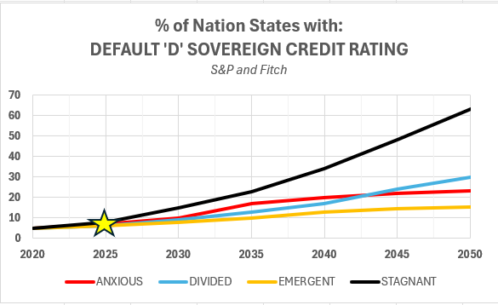

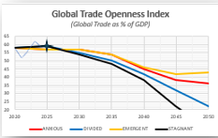

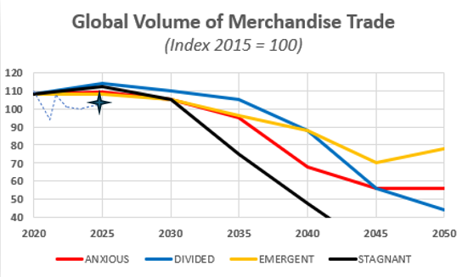

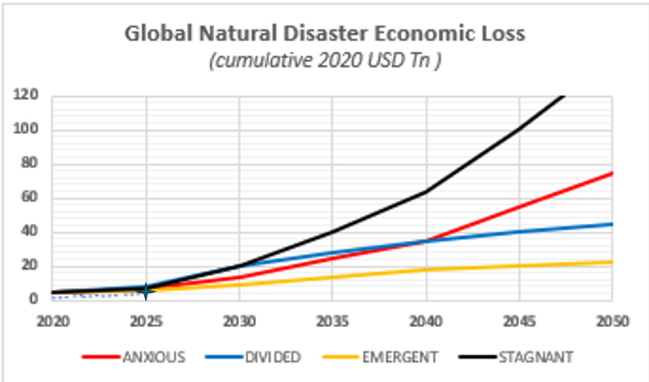

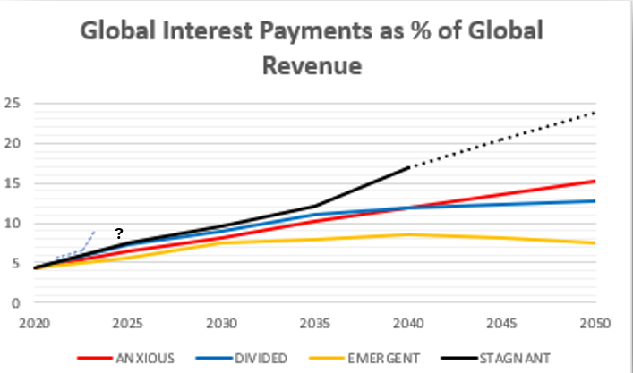

INEVITABLE CONSEQUENCES
POLITICAL
GRAPHS
2025 Update

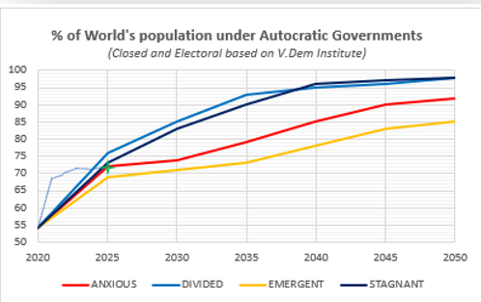

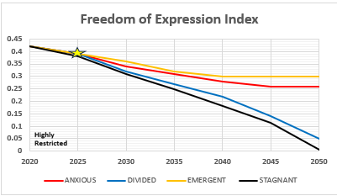

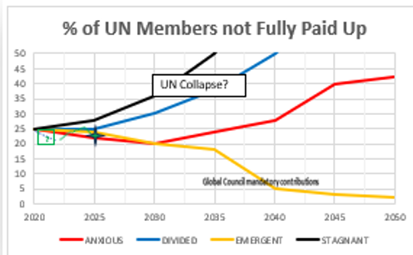

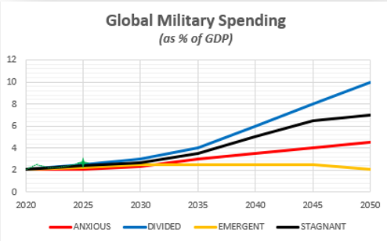

INEVITABLE CONSEQUENCES
SOCIAL
GRAPHS
2025 Update

