***THE SEGMENTED WORLD PROJECT***

***The ‘real’ Segmented World***

**Scenario GRAPHS**

***GLOBAL DRIVERS***

***GRAPHS***

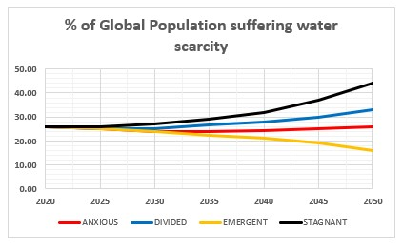

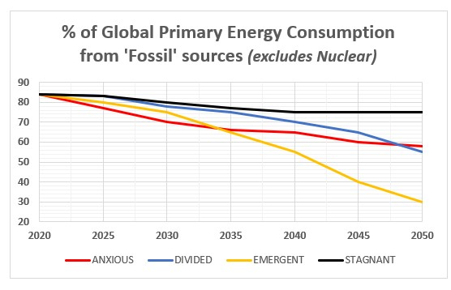

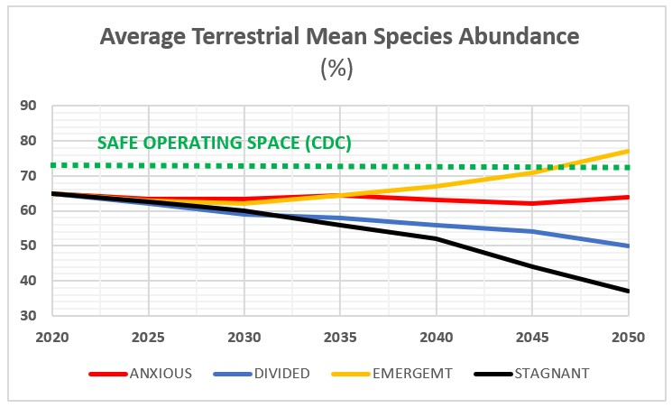

***INEVITABLE CONSEQUENCES***

***ECONOMIC***

***GRAPHS***

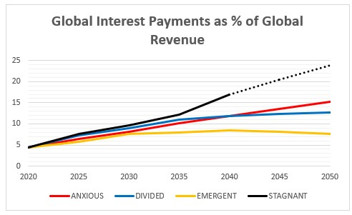

***INEVITABLE CONSEQUENCES***

***POLITICAL***

***GRAPHS***

***INEVITABLE CONSEQUENCES***

***SOCIAL***

***GRAPHS***

***THE SEGMENTED WORLD PROJECT***

***The ‘real’ Segmented World***

**AVERAGED GRAPHS**

***GLOBAL DRIVERS***

***GRAPHS***

***INEVITABLE CONSEQUENCES***

***ECONOMIC***

***GRAPHS***



***INEVITABLE CONSEQUENCES***

***POLITICAL***

***GRAPHS***

***INEVITABLE CONSEQUENCES***

***SOCIAL***

***GRAPHS***

D

